Business case

The purpose of this document is to outline how the proposed system solves a real-world problem, project objectives, risk analysis as well as related systems analysis, and the overall project plan – including scope and deliverables.

**1.1 Optimising GBV Incident Reporting**

Gender-Based Violence (GBV) is a prevalent and growing concern in South Africa. South Africa has one of the highest rates of GBV in the world, with daily reports of attacks, harassment, and femicide making the news and showing up in national statistics. People of all ages, genders, and economic standings are victim to this crime, creating a major human rights crisis and societal worry.

A crucial issue in addressing GBV situations is the process of reporting. There is usually either a fear of safety due to the lack of anonymity, a fear of stigma due to societal judgement, mistrust in the existing aid available for victims, or limited access to accessible avenues. In under-resourced areas, they are faced with issues such as lack of responsive and instantaneous support services or having police stations distanced far away from them.  
  
The result of this is under-reported GBV cases, leaving victims feeling silenced as well as preventing support services such as police and NGOs from responding effectively. Due to the lack of reliable reporting channels, data on GBV instances are inadequate, preventing the ability for organizations to design interventions, allocate resources properly, and protect vulnerable groups.

**1.2 Project objectives**

The GBV Reporting App aims to address critical real-world problems in South Africa’s gender-based violence (GBV) reporting and support system. Below are the key objectives of the software intervention:

**1. Enable Anonymous & Secure Reporting**

Problem: Many survivors fear retaliation, stigma, or distrust authorities, leading to underreporting.

Solution:

- Provide end-to-end encrypted, anonymous reporting to protect user identities.

- Offer a stealth mode (disguised app icon) for safety.

**2. Improve Accessibility of Reporting**

Problem: Physical reporting (police stations, helplines) is often unsafe, distant, or unavailable.

Solution:

- Mobile-first platform for real-time incident reporting anytime, anywhere.

- Offline-first capability (store reports if no internet, sync later).

**3. Enhance Emergency Response with Location Data**

Problem: GBV hotspots are poorly mapped, delaying interventions.

Solution:

- GPS tagging of incidents to identify high-risk areas in real time.

-SOS panic button for users in an emergency situation.

**4. Bridge the Gap to Support Services**

Problem: Survivors struggle to find shelters, legal aid, or medical help quickly.

Solution:

- Integrated directory of verified support services (NGOs)

- Secure messaging between survivors and support providers.

**5. Overcome Language & Literacy Barriers**

Problem: Many survivors speak indigenous languages or have low digital literacy.

Solution:

- Multilingual interface (Zulu, Xhosa, English, etc.).

-Option of voice messaging for those who have low literacy.

**1.3 Problem background: A Literature Review of GBV and Technological Interventions in South Africa**

Gender-Based Violence (GBV) in South Africa stands as one of the most complex and long-standing issues of the society. The World Health Organization (2013) articulates any form of violence that inflicts physical, sexual, or psychological damage as GBV. Despite numerous attempts to resolve the crisis, the systems meant to help, including the police, courts, and social services, remain deeply entrenched in their own issues. This review aims to first describe the immense scope of the GBV crisis, as well as the systemic failures in the state's response. After that, explain how these failures create a compelling rationale for technological solutions that default to broken systems and offer survivors safe, anonymous, and accessible avenues to vital assistance.

**The Scope of the Crisis and the Failure of Conventional Systems**

The evidence-based research of GBV in South Africa portrays a fundamentally alarming picture. The pivotal study by Abrahams et al. (2013) indicated that South Africa’s homicide rates showed the greatest proportion of females relying on intimate partners for economic and psychological violence. Objectively, the Machisa et al. (2011) study also discovered that GBV is rampant. In relation to the pandemic, the majority of women in South Africa in 2020 reported having experienced some form of violence at some point in their lifetime.

The published statistics from SAPS Q3 2022/23 Crime Statistics (2022) indicate thousands of cases, but these statistics greatly underestimate the actual figures. This underreporting is clearly a sign of a well-documented system failing. Vetten’s (2005) budgetary analysis, “Show me the money,” described how funds allocated to the Domestic Violence Act (DVA) resulted in severely under-implemented policies, which in turn, funded the Act’s implementation ineffectively. This analysis is made worse by a criminal justice system defined by police inaction, ineffective prosecution, and secondary victimization, as mentioned in the discussion paper by the South African Law Reform Commission (2023). For a survivor, the rational option is to not report, and if they do, they are likely to experience more trauma and have very little chance to achieve justice.

**The Need for Technology**

In the case of systemic failures, technology is not an option, but rather a necessity. Where traditional avenues are untrustworthy or ineffective, digital options provide an essential alternative. The primary value promise of a technological intervention is the ability to overcome, or remove the barriers, which have been documented:

* Anonymity and Safety: Technology can remove the stigma and fear of retaliation that reporting might invoke (Machisa et al., 2011). As compared to the police stations or calls that can lack privacy, a mobile app can provide a confidential space that is feared less.
* Accessibility: Geographic isolation and a lack of resources (Vetten, 2005) no longer pose issues with the presence of mobile phones. An app can offer information and a reporting tool that is useful 24/7 and that can literally be kept in a survivor’s pocket.
* Bypassing Systemic Failures: Support services (shelters, legal aid, clinics) can be accessed through underfunded state infrastructures. Technology can provide direct access to a directory, thus offering bridges that bypass the gaps created by lacking infrastructure and provide direct access to aid for survivors.
* Data and Accountability: Technology can be harnessed to generate critical data, even where traditional systems fail to allocate resources effectively (Vetten, 2005). Anonymized reporting can expose risk areas and map trends, enabling NGOs and policymakers to advocate for and target resources where they are most needed.

**Technology as a Bridge**

The literature unequivocally confirms that the conventional pathways to safety and justice for GBV survivors in South Africa are broken. The gap between the promise of the law and the reality of implementation is vast. This failure creates a clear and justified role for technological solutions. A well-designed mobile application is more than a tool; it is a necessary intervention designed to bypass documented systemic failures. By offering a secure, anonymous, and accessible first point of contact, it addresses the primary barrier of underreporting identified by all the provided sources. Such an intervention empowers survivors with immediate agency and helps generate a more accurate picture of the crisis, creating a bridge between a state of crisis and the support that survivors are currently denied.

**1.4 Related systems analysis**

When researching what other GBV software systems are readily available in South Africa, we came across three widely used applications – Bright Sky SA, GRIT, and Namola.

Bright Sky SA is a mobile application available for both Android and iOS devices and was created during the COVID-19 pandemic when gender-based violence in homes sky-rocketed. It is focused on helping victims or bystanders report GBV incidents through the app. The app also offers a questionnaire section, enabling users to understand what kind of GBV they are experiencing, the different support services that are available for them, as well as a range of case studies for educational purposes. Figure 1 demonstrates the Covert Mode screen which promotes anonymity for users on the app.

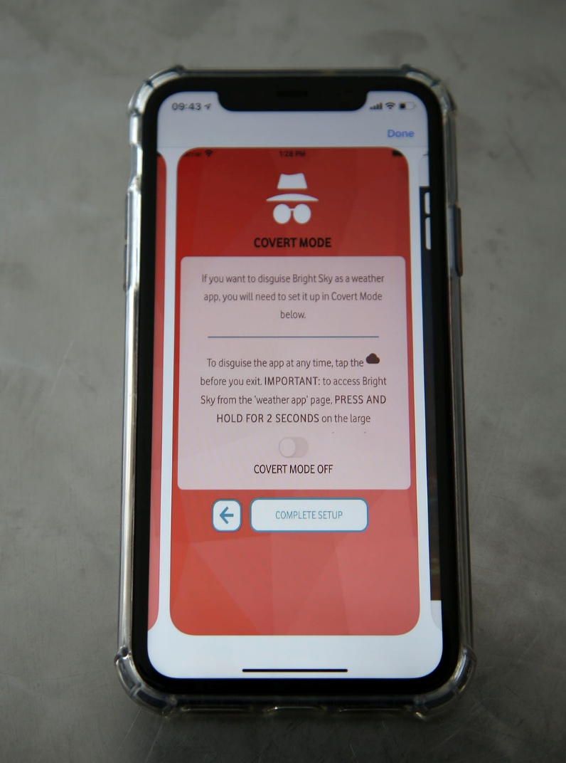

Figure 1: Bright Sky SA Covert Mode screen

Features that we would like to incorporate into our system:

* Users are not subject to data costs when using the app due to the zero-rated feature.
* Privacy of personal user information.
* The dedicated support and resources section provided for the user.
* ‘Covert’ mode – allowing users to stay anonymous.

Features that we would like to avoid:

* This app is not designed for emergency situations. We would like to have this option for users who find themselves in a dangerous situation.
* It acts more as an information hub than a direct reporting tool. Sometimes an abundance of information and resources can be overwhelming for users – we would like to have a balance of both an information and reporting section.
* The app does not act as a direct channel to authorities such as police and NGOs. It shows the user where they can find help near them, but we would like users to have that direct access to help services.

GRIT (Gender Rights in Tech) is an Android and iOS application that provides a secure and confidential way for survivors to report a GBV crime, as well as allowing them to have access to support services. It contains a panic button, a database that can store up to ten years of evidence, and a chatbot (as seen in Figure 2) that aids victims in speaking about their situations without fear of stigma, allowing them to gain some useful legal and health advice.

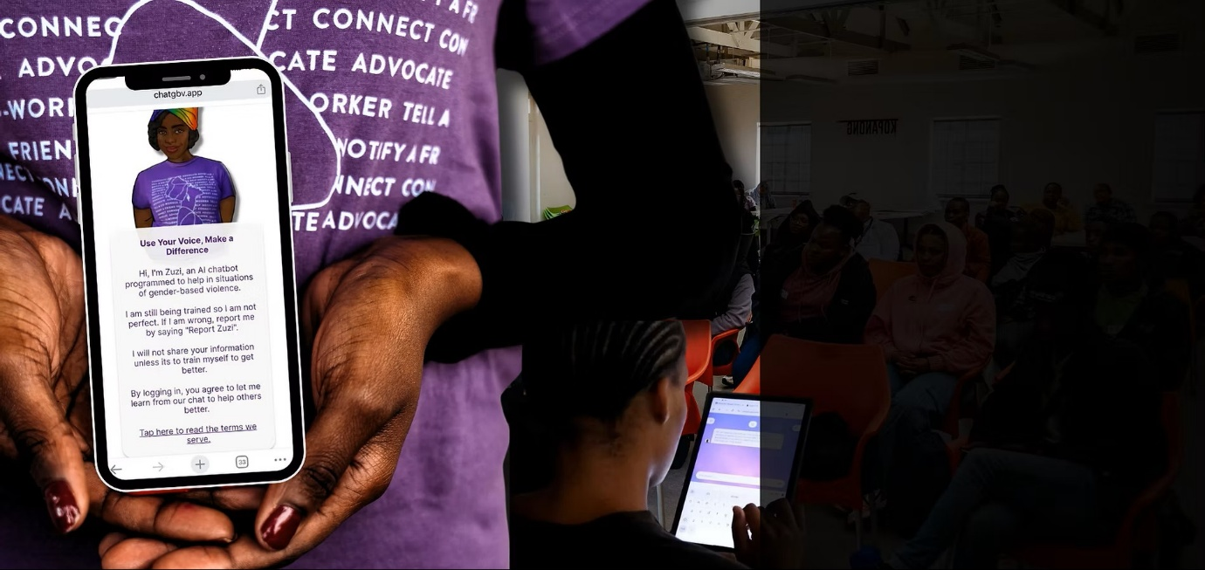

Figure 2: GRIT Chatbot Screen

Features that we would like to incorporate into our system:

* The panic button for immediate location tracking and emergency response.
* Ability of long-term storage in a secure manner.
* Accessibility through the ‘no cost’ approach in regard to the app and data usage

Features that we would like to avoid:

* The use of a centralised vault for evidence storage. It would be beneficial for the user to store evidence on their local device.
* High dependency on emergency armed response. Our aim is to provide a more inclusive approach for users to either contact emergency services or their trusted contacts.

Namola is accessible to mobile Android as well as Apple users and provides instantaneous access to emergency services. The press of a button will enable the user to access services such as the police, fire department, ambulance, and traffic officers. This application ensures a quick and reliable outcome for those who find themselves in a crisis. It does not only specialise in GBV, but many other situational incidents – such as fires, wellbeing, and safety. Figure 3 shows the community screen included in the Namola application, allowing for users to stay updated on any reports or incidents in and around their city.

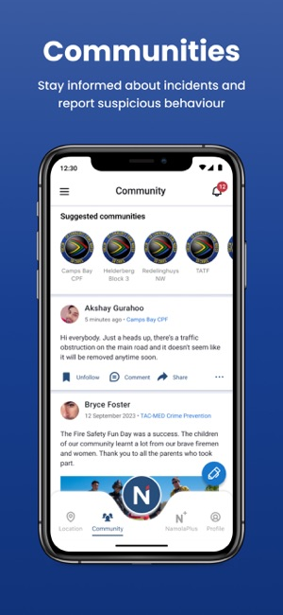

Figure 3: Community screen on Namola

Features that we would like to incorporate into our system:

* Sharing user location to emergency services
* SOS button for immediate response from emergency services
* ‘Sensitive Mode’ which allow users to stay anonymous in their reports.

Features that we would like to avoid:

* The broad emergency response rather than focusing on GBV crimes does not align with the goals of our application.
* Namola Plus, a paid subscription which provides private armed response, limits the accessibility that we are aiming to achieve with our application.
* The spotlight on armed response, with no access to NGO support, can result in a GBV survivor feeling as if they cannot report their situation in a safe and discreet manner.

**1.5 The project plan**

**Project Information**

**Project Name:** GBV App

**Company Name:** Tech4Change

**Project Team:**  Zanele Shandu, Jasmin Storm, Mthi Mzimba

**Client Name:** Jane Doe Inc.

**Sponsor:** TrulyUni Foundation

**Stakeholders:** AllOurGirls Organisations, NoTears Foundation

**Project Manager:** Zanele Shandu

**Delivery Date:** 31 October 2025

**Version:** 1.0 (Prototype)

**Project Scope**

The project aims to produce a mobile GBV reporting app that allows users to confidentially report incidents and contact with necessary resources with end-to-end encryption. The app enables NGOs and similar parties to manage and respond to reports effectively, while also analysing data to track trends and identify high-risk patterns. Security best practices are to be used at the database level to ensure privacy and data security; thus the system prioritizes confidentiality and empathy at every step.

**Key Milestones**

|  |  |  |
| --- | --- | --- |
| **Milestone** | **Deliverable** | **Delivery Date** |
| 1. Project Definition | Requirements Documents (Problem Scope & Business Case) | 29 Aug 2025 |
| 1. System Design | Architecture & ERD Diagram | 14 Aug 2025 |
| 1. Backend Setup | API + Database Connectivity | 1 Sept 2025 |
| 1. Front-end Integration | Front-end is linked with backend API endpoints (eg: POST/messages) | 10 Sept 2025 |
| 1. Middleware & Services | Core Services (User Authorisation, Reporting, Messaging, Resources,) | 15 Sept 2025 |
| 1. Front-end Framework & Integration | Usability Layer | 10 Oct 2025 |
| 1. Testing & Feedback | User Testing & Bug fixes | 14 Oct 2025 |
| 1. Final Delivery | Presentation & Project Handover | 31 Oct 2025 |

**Gantt Chart**

|  |  |  |  |  |
| --- | --- | --- | --- | --- |
| **Milestone** | **Delivery** | **Dependencies** | **Start Date** | **End Date** |
| 1. Project Definition | Requirements Documents (Project Proposal & Business Case) | Business Strategy | 11 Aug 2025 | 29 Aug 2025 |
| 1. System Design | Architecture & ERD Diagram | Requirements Documents | 6 Aug 2025 | 14 Aug 2025 |
| 1. Backend Setup | API + Database Connectivity | Architecture & ERD | 16 Aug 2025 | 1 Sept 2025 |
| 1. Front-end Integration | Front-end is linked with backend API endpoints (eg: POST/messages) | API endpoints | 3 Sept 2025 | 14 Sept 2025 |
| 1. Middleware & Services | Core Services (User Authorisation, Reporting, Messaging, Resources,) | API endpoints & Database Connectivity | 4 Sept 2025 | 15 Sept 2025 |
| 1. Front-end Framework & Integration | Usability Layer | Front-end framework, Core Services | 18 Sept 2025 | 10 Oct 2025 |
| 1. Testing & Feedback | User Testing & Bug fixes | Comprehensive HiFi prototype | 12 Oct 2025 | 14 Oct 2025 |
| 1. Final Delivery | Presentation & Project Handover | Completed Program. | 20 Oct 2025 | 31 Oct 2025 |

**1.6 Risk Analysis**

During the process of brainstorming our app, we have found potential risks that would affect the app and those who use it. When risks are identified, it would then need to be decided how those risks will be handled. Therefore, it is important that we identify some of these risks to ensure it is easier for us to determine which risks are preventable or are of higher importance. These risks can be divided in four categories:

**Acceptable risks:** Fake reports would fall under this category as it would be too costly and resource-heavy to fully prevent them and would possibly deter genuine users from using the app. Overall, it would be more beneficial to accept that there will be a few fake reports which would be outweighed by the genuine ones.

**Avoidable risks:** Loss of data is an avoidable risk due to the preventable actions that can be taken such as ensuring backups are frequently occurring and stored in multiple locations securely. Another risk could be the lack of awareness of our app, which can be avoided by implementing awareness drives where communities know more about it.

**Minimizable risks:** Although privacy violations are not completely avoidable, there are steps that can be taken to minimize the impact or occurrence of them. Using encryption and secure authentication can reduce privacy violations and protect the confidentiality and integrity of user data.

**Transferable risks:** In the context of our GBV app, a big transferable risk would be the legal or compliance issues. Instead of having an incident where we would break the law or have an oversight, we would rather transfer that responsibility to NGOs and or legal advisors who have the expertise to manage it in a professional manner.

**1.7**

# References

Abrahams, N., Mathews, S., Martin, L. J., Lombard, C., & Jewkes, R. (2013). Intimate partner femicide in South Africa in 1999 and 2009. *PLoS Medicine*, , 10(4), e1001412. Retrieved from https://doi.org/10.1371/journal.pmed.1001412.

GRIT. (n.d.). *Our Tech*. Retrieved from Grit GBV: https://www.grit-gbv.org/technology

Machisa, M., Jewkes, R., Lowe-Morna, C., & Rama, K. (2011). (2011). *The war at home: Gender based violence prevalence study.* Johannesburg, South Africa.Retrieved from https://www.saferspaces.org.za/uploads/files/GenderLinks-13452_begin_war_at_home.pdf: Gender Links & South African Medical Research Council.

Namola. (n.d.). *Namola Safety App*. Retrieved from Namola: https://www.namola.com/

SALRF. (2023). *Domestic violence: The criminal law response (Discussion Paper 161, Project 100).* South African Law Reform Commission.Retrieved from https://www.justice.gov.za/salrc/dpapers/dp161-prj100-DV.pdf.

SAPS. (2023). *SAPS Q3 2022/23 Crime Statistics, with Ministry.* Parliamentary monitoring Group.Retrieved from Parliamentary Monitoring Group: https://pmg.org.za/committee-meeting/36339/.

Vetten, L. (2005). ‘Show me the money’: A review of budgets allocated towards the implementation of South Africa's Domestic Violence Act. *Politikon South African Journal of Political Studies*, 32(2):277-295.Retrieved from https://www.researchgate.net/publication/233050565_'Show_me_the_money'_A_review_of_budgets_allocated_towards_the_implementation_of_South_Africa's_Domestic_Violence_Act.

Vodacom. (n.d.). *Popular Pages*. Retrieved from Vodacom zero-rates Bright Sky SA gender-based violence awareness app | Vodacom Group: https://www.vodacom.com/news-article.php?articleID=7594#:~:text=JOHANNESBURG%20%2D%20As%20part%20of%20its,services%20such%20as%20Bright%20Sky.

WHO. (2013). *Global and regional estimates.* World Health Organization.Retrieved from https://iris.who.int/bitstream/handle/10665/85239/9789241564625_eng.pdf?sequence=1.

Women’s Tech Network. (2022). *Safety tech and design: Best practices for DV apps*. Retrieved from Women’s Tech Network: https://womentechnetwork.org/reports/safety-tech-design